
PHASE I SOURCE REPORT
EDUCATIONAL ASL GAME

July 6, 2026
JAKOB COX, YEABTSEGA TENA, TANJAI PLOYKAO
CMSC 495

Summer 2026

Table of Contents
Project Overview 2
Introduction 2
Objective 2
Instructions: Review the Phase I Requirement 2
Design Software Architecture 3
Implement the Software 4-8
Test Software 9-10
Test Cases 11-12
Conclusion 13

CMSC 495 Phase I Source Code

Project

ASL Farm — an educational 2D game built in Godot 4.6 that teaches American Sign Language (ASL) fingerspelling. The player explores a small farm, interacts with a newspaper to learn new signs, and interacts with trees to be quizzed on signs already learned. Correct answers grow a tree; incorrect answers cause it to regress, giving the player a visible, ongoing incentive to retain what they've learned.

Introduction

Our team applied agile development methodologies throughout, iterating week over week rather than attempting to fully specify the system up front. Early weeks focused on project scaffolding, risk and role assignment, and a UML-level design of how the game's scenes and data would relate to one another. Once that design existed, even in incomplete form, implementation began immediately and iteratively: the character controller was built first since every other feature depends on it, followed by the interactable-object framework that governs how the player engages with anything in the world, then the ASL data layer, and finally the quiz and learning UI logic that surfaces that data to the player. Each of those pieces was treated as a separate, individually testable increment rather than one large monolithic build, which is what allowed problems to be caught and corrected in isolation rather than discovered all at once at the end.

Objective

The objective of this Phase I Source document is a walks through of all the process: the requirements this phase was scoped against, the architecture that resulted, what was actually implemented, how it was tested, and a representative sample of the source code itself.

Instructions

- Review the Phase I Requirements
Before any implementation began, the team reviewed the Phase I requirements to establish exactly what "done" would mean for this stage of the project. The project scope for Phase I was intentionally narrow: design and implement the foundational gameplay loop for an educational ASL game, rather than a feature-complete product. That loop was broken into three concrete pieces — player characterization/ movement, a general-purpose interaction system usable by any object/class in the world, and two learning mechanics (a "learning" screen for introducing new signs, and a "quiz" screen for reinforcing signs already introduced) — all built on top of a single, shared ASL sign data set rather than duplicated per-object data.

Reviewing these requirements up front served two purposes. First, it forced an early decision about what was explicitly out of scope for this phase — final art assets, a day/night or time system, and win/lose conditions were all identified as later-phase concerns, which kept the team from being blocked by dependencies (such as finished artwork) that were outside the team's immediate control. Second, it defined the deliverable and success criteria in behavioral terms rather than structural ones: the deliverable was a playable prototype, and success was measured by whether a player could walk to an object, trigger a learning or quiz interaction, and see that interaction's outcome — new signs displayed, or a tree visibly growing or shrinking — actually reflected in the running game. A script existing was not treated as sufficient evidence of progress; the loop had to be observable end-to-end.

- Design the Software Architecture
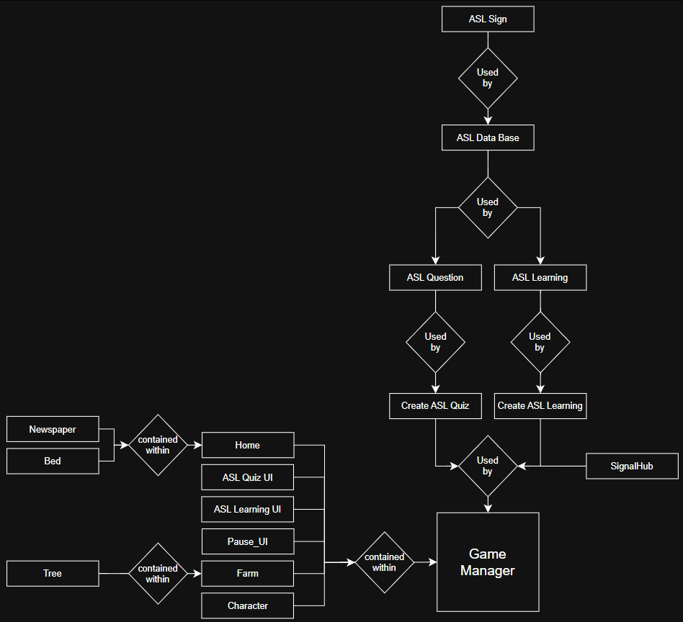

- Implement the Software

- Handling Interaction

When the player presses the interact key Handle_interact is given a String that will match what object the player is interacting with.
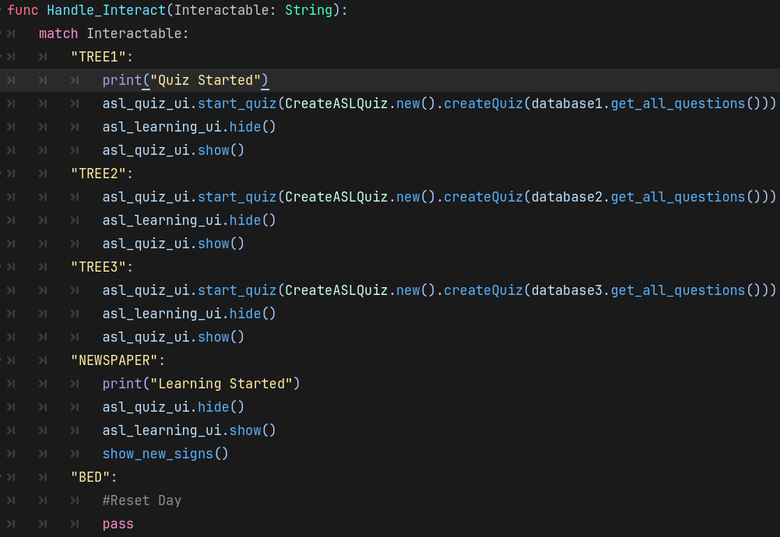

- ASL Quiz Functions
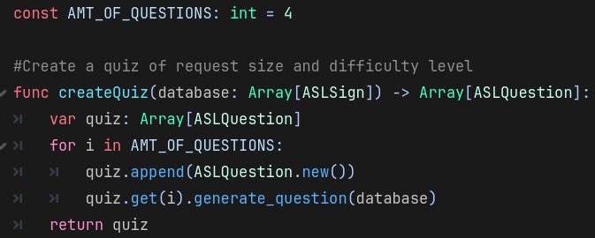
Creates an array of an object called ASLQuestion

When and ASLQuestion object is created and ASLQuestion.generate_question(Array[ASLSign]) is called it sores 4 ASLSigns from the ASL Data base into question.
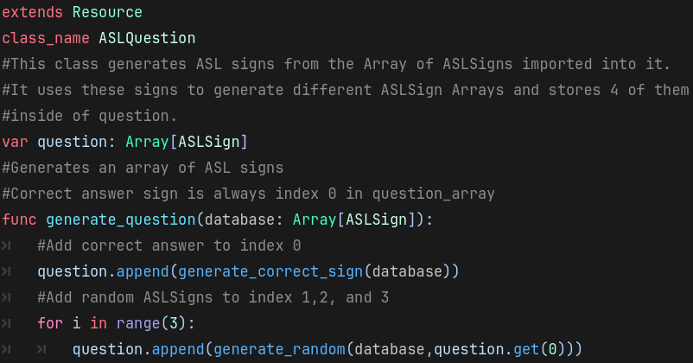
Resets quiz and calls function to start display the first ASLQuestion in the array given to it.
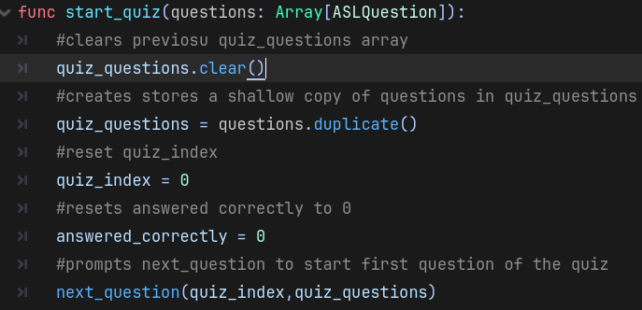

Calls a func to randomly determine the type of question displayed, also emits a signal that the game_manager uses to end the quiz and hide the UI.
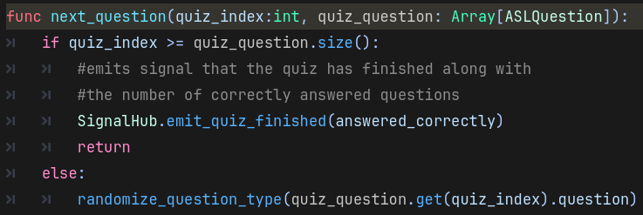

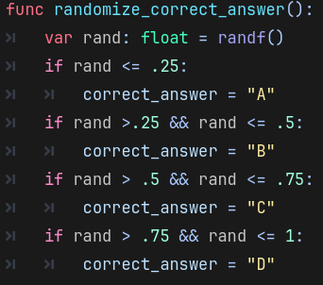
Is used to randomize which button the correct answer will be assigned to.

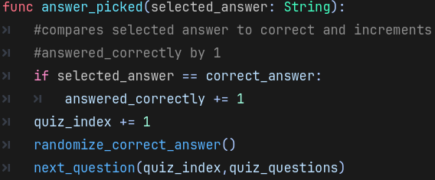
Is called when the players presses one of quiz answer buttons. It randomizes the next correct answer and calls next_question with the upated index.

- ASL Learning Function
Updates UI to show new signs based on whether a data base of a certain difficulty has been fully completed or not.

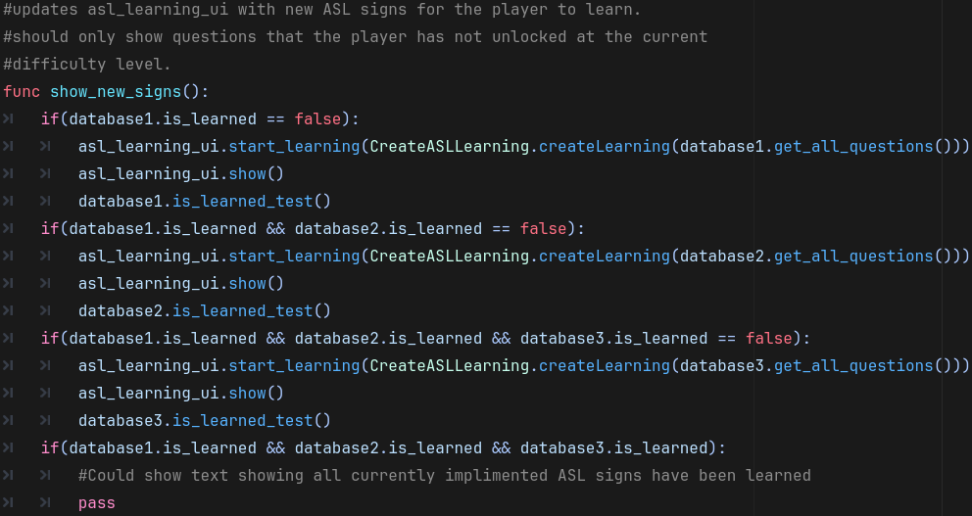

Used to create an Array of 4 ASLSigns

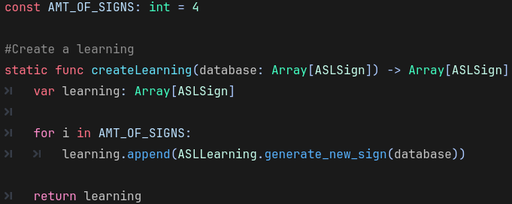

Used to retrieve an ASLsign that the player has not currently unlocked. Also, unlocks the new sign for the player.

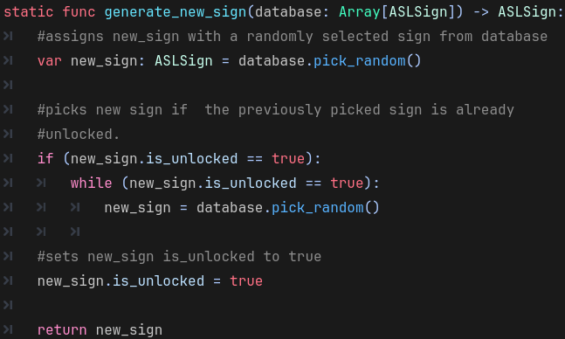

Displays new signs given to it by game_manager.

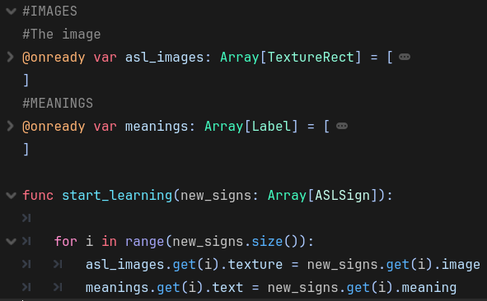

- Test the Software

We are going to use functional testing, integration testing, system testing, usability testing, and User Acceptance Testing (UAT) as testing method for game to verify that the ASL game works.

Functional Testing
Test Case | Player Input | Expected Result
Test player movement | Press W/A/S/D or arrow keys | Player moves in the correct direction
Test collision object | Player walks to the wall | Player should not go past the wall
Test loading | Player click load save or load key | Player loaded save
Test newspaper interaction | Walk to newspaper and press interact key | Newspaper opens and shows ASL sign with meaning
Test quiz answer | Select correct quiz answer | Game marks answer correct and increases correct-answer count
Test pause menu | Player click pause or  press pause key | Pause UI appears and game pauses
Integration Testing
Test Case | Player Input | Expected Result
Newspaper to quiz connection | Learn sign from newspaper, then interact with tree | Learned sign appears in quiz questions
Quiz to tree growth | Answer quiz correctly and answer quiz incorrectly | Tree growth stage increases when correct.  Tree growth stage decreases when incorrect.
Door transition | Walk into farm/home door area | Game transitions to correct scene
Pause signal | Press pause key | Signal triggers Pause UI correctly
System Testing
Test Case | Player Input | Expected Result
Complete full gameplay loop | Start game, then read newspaper, then learn sign, then take quiz, then grow tree | Player can complete the full learning cycle without errors
Main menu flow | Start New Game from menu | Game Manager loads and player enters game scene
Usability Testing
Test Case | Player Input | Expected Result
UI readability | Player views newspaper and quiz screen | Text and images are easy to read
User Acceptance Testing
Test Case | Player Input | Expected Result
Requirement: ASL learning | Player reads newspaper | Game teaches ASL sign and meaning
Requirement: Quiz system | Player interacts with tree | Multiple-choice ASL quiz appear
Requirement: Progression | Player answers correctly | Trees grows as learning progress
Requirement: Scene transition | Player moves between Home and Farm, and Main | Correct scene loads
Requirement: Pause/Quit | Player opens pause menu and selects quit | Game exits or returns properly

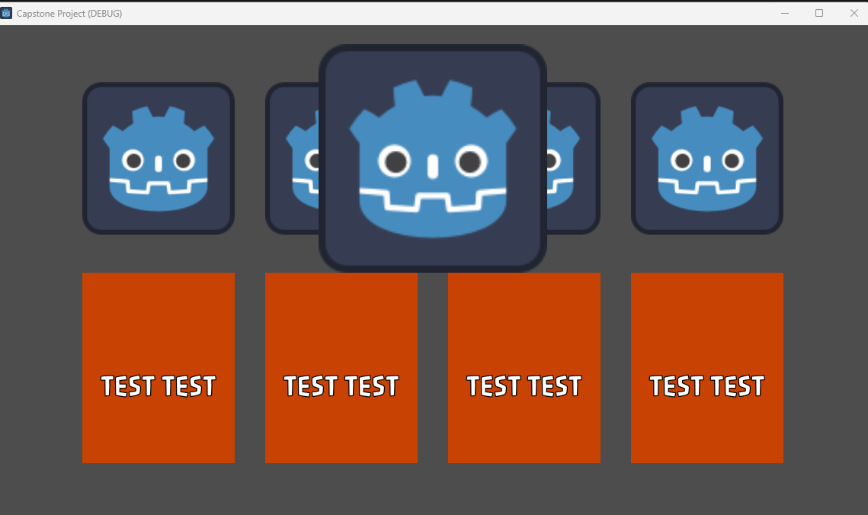

The following screenshots are the game current progress when user click “Run” the program.

TEST CASES

Feature: ASL Learning Generation

Objective: Verify 4 ASLSign images and meanings are shown.

Preconiditions:

- database1 contains an array of 4 ASLSign’s. “A”,”B”,”C”, and “D” that are not unlocked.
- Unhandled input TEST_ACTION calls Handle_Interact(“NEWSPAPER”)

TestSteps:

- Start game
- Press shift+T

Expected Results:

The screen should display 4 ASL signs to the player. Both their meaning and image should be shown

Actual Result:

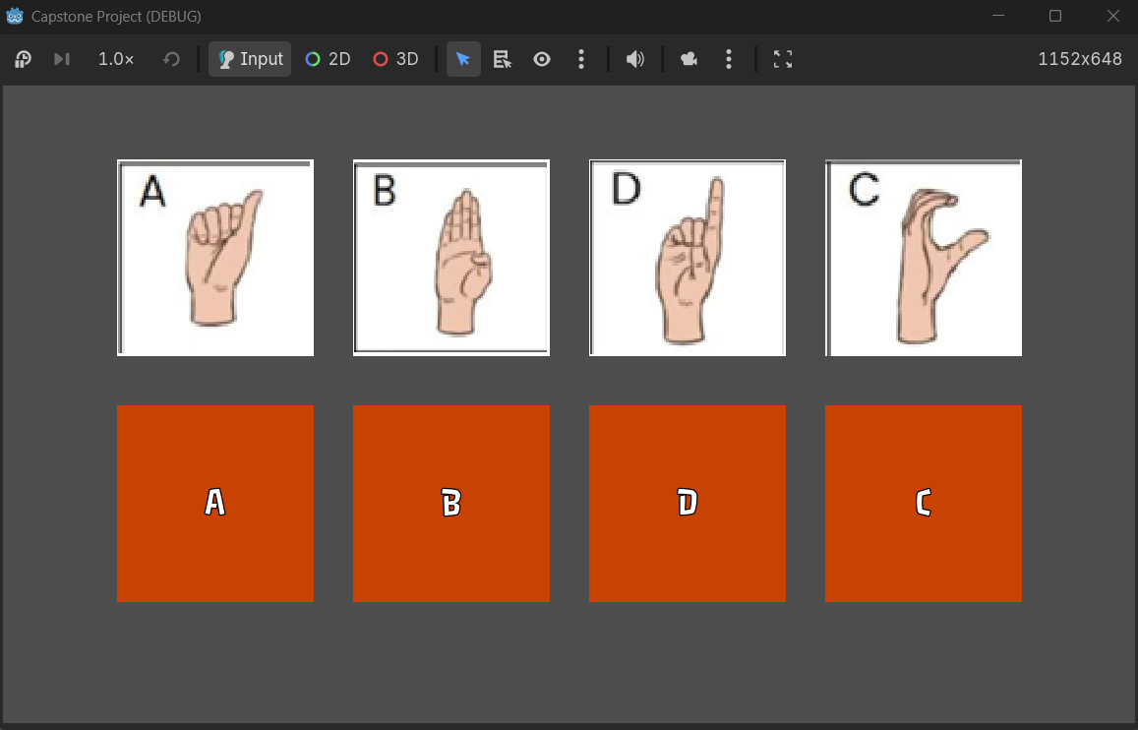

Status: PASS

Feature: ASL Quiz Generation

Objective: Verify 4 ASLSign images and meanings are shown and quiz cycles through different questions and question types.

Preconditions:

- database1 contains an array of 4 ASLSign’s. “A”,”B”,”C”, and “D” that are unlocked.
- Unhandled input TEST_ACTION calls Handle_Interact(“TREE1”)

TestSteps:

- Start game
- Press shift+T
- Answer questions displayed on screen until no questions are displayed

Expected Results:

The screen should display either an image prompt with 4 meanings or a meaning prompt with 4 images. The player should be able to click on one of the 4 answers and the quiz should present a new question. This should be done 4 times, since this is the size of generated by CreateASLQuiz.

Actual Result:

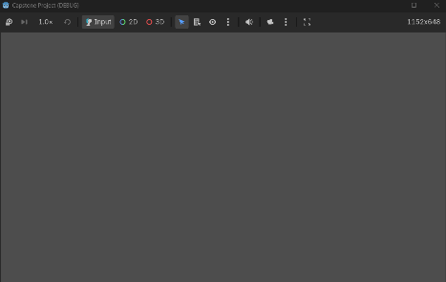
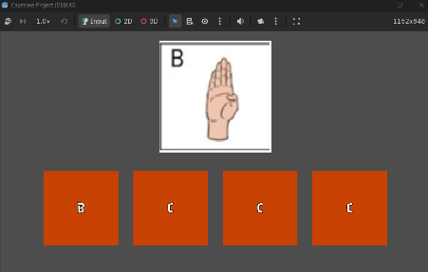
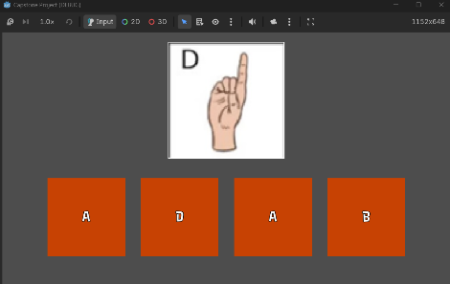

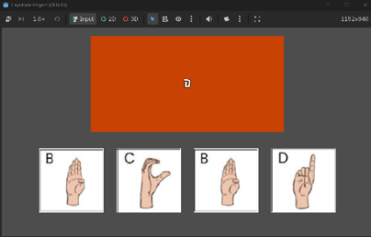
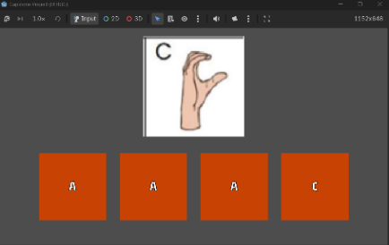

Status: PASS

Conclusion

In conclusion, Phase I successfully established the core functionality of the ASL educational game. The implemented features such as player interaction, the ASL learning system, the ASL quiz system, and the supported data structure used to manage the ASL image signs. These test cases are the prove that these core features function as expected and meet the Phase I requirement. Overall, the project provides a stable foundation for Phase II, where additional gameplay features, user interface improvement, game progression and expanded ASL content will be implemented or added into it.

